POWERPOINT ASSIGNMENT 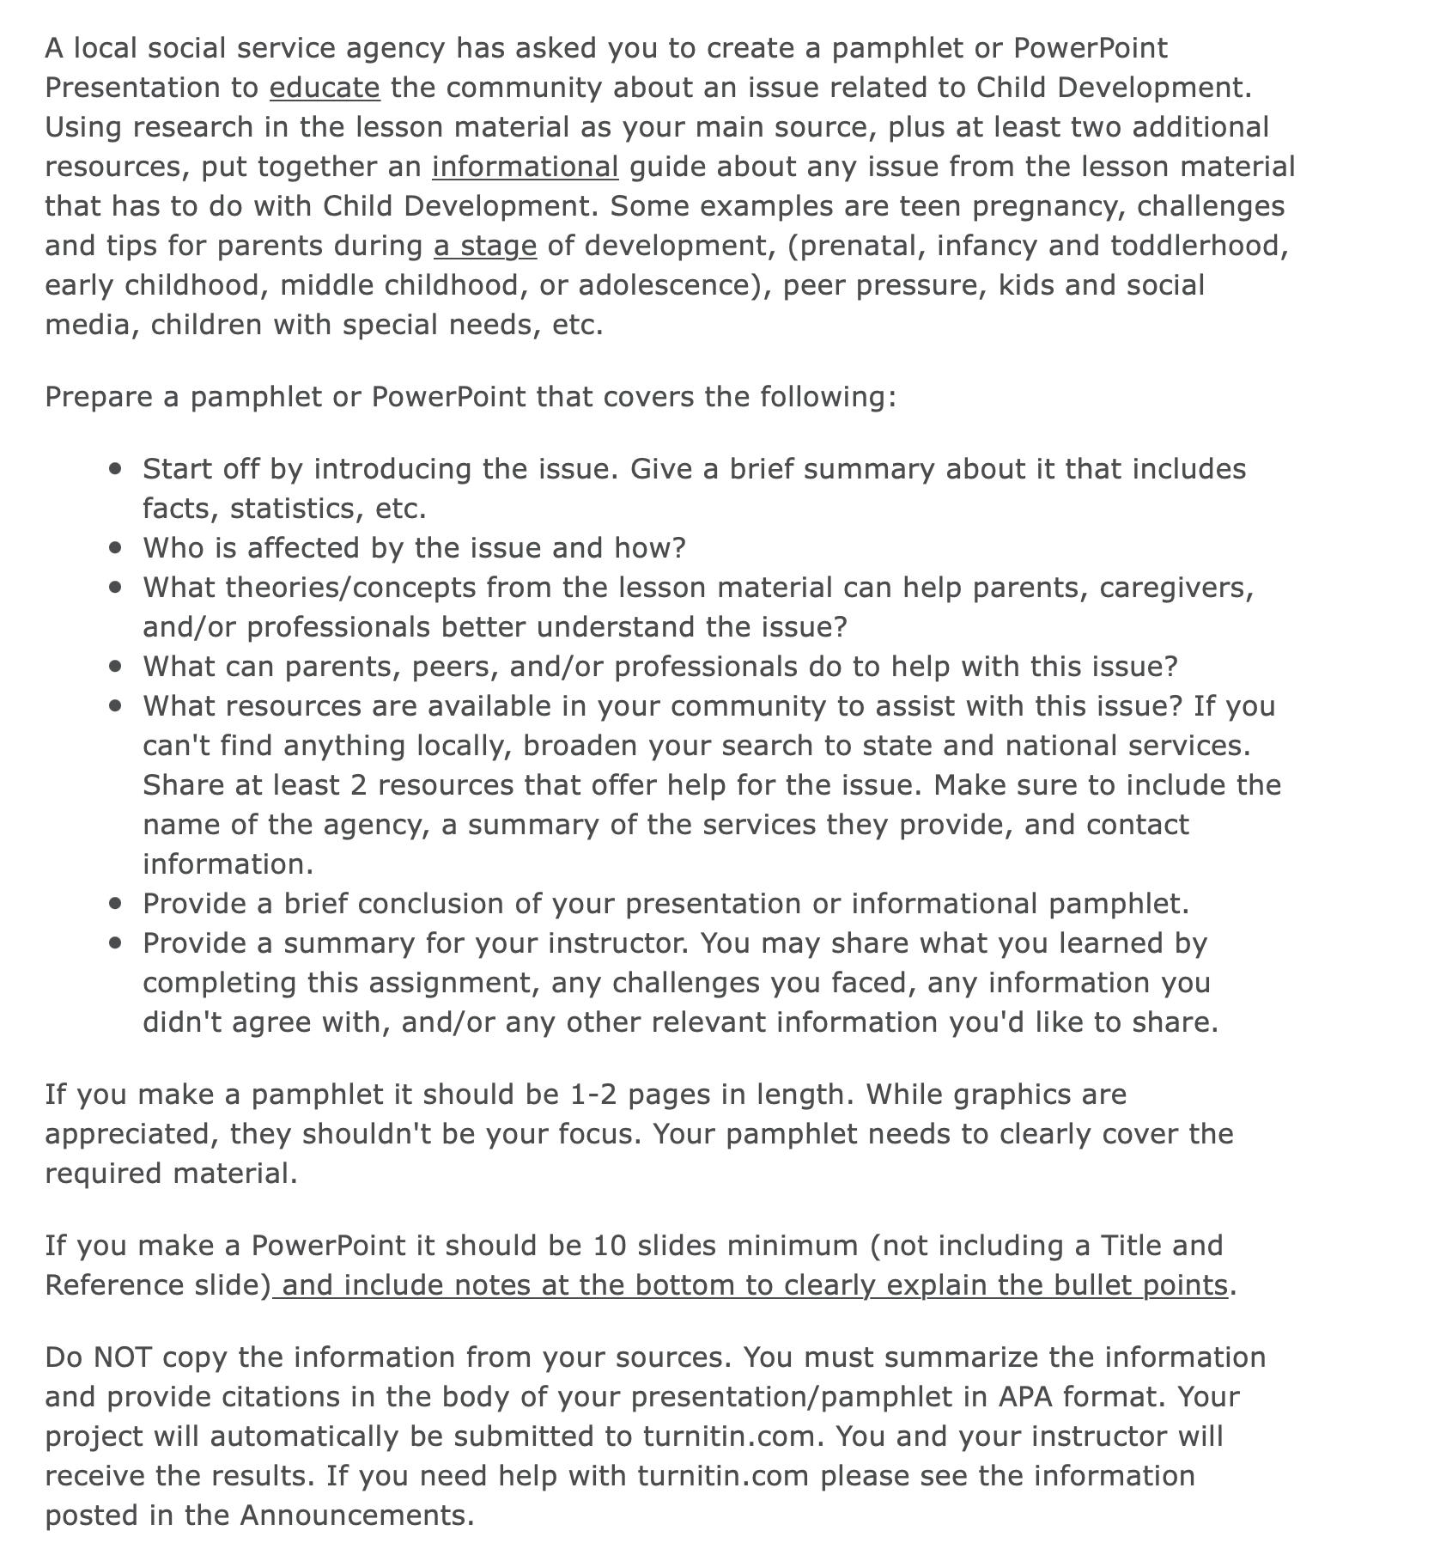

REQUIRED SOURCES TO USE:
(This is a list of sources required to use in the PowerPoint. Proper APA 7th ed formatting will be done by you. I have added pages I screenshotted from the lesson. I have included the completed APA source for that as well as the intext citation. Please make sure you use in text citations within the PowerPoint. But don’t overdo it.

YOU ARE REQUIRED TO PROVIDE AT LEAST 2 ADDIATIONAL RESOURCES THAT YOU MUST FIND RELATED ON THE TOPIC.

- https://www.cdc.gov/teenpregnancy/about/index.htm <--- USE THIS AS WELL

Reference for info on this page:
CHFD215 (2021). Week 3: Physical Growth, Sexual Differences and Gender Roles. American Public UniversitySystem. https://myclassroom.apus.edu/d2l/le/enhancedSequenceViewer/38522?url=https%3A%2F%2Ff54cbe36-23a9-4505-85fe-e251f80ec34d.sequences.api.brightspace.com%2F38522%2Factivity%2F4146712%3FfilterOnDatesAndDepth%3D1
IN TEXT CITATION: CHFD215 (2021)
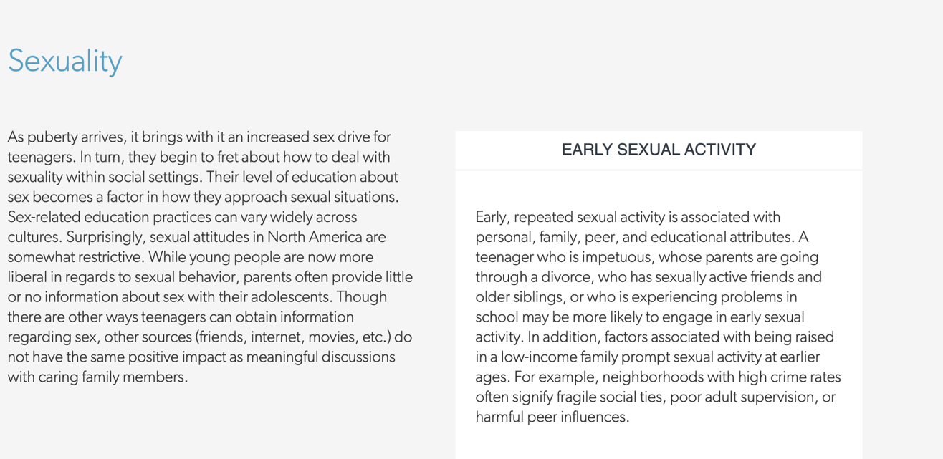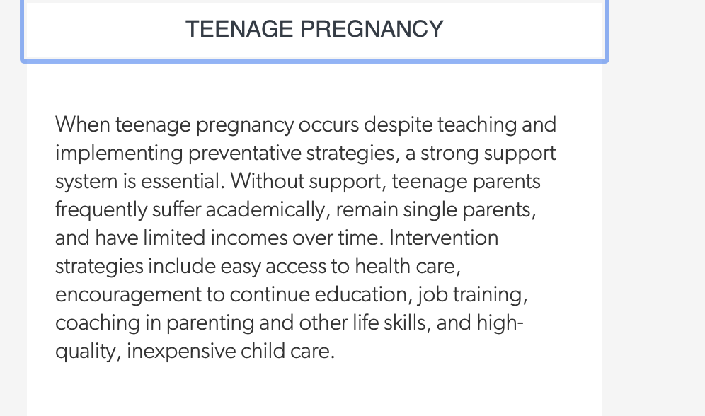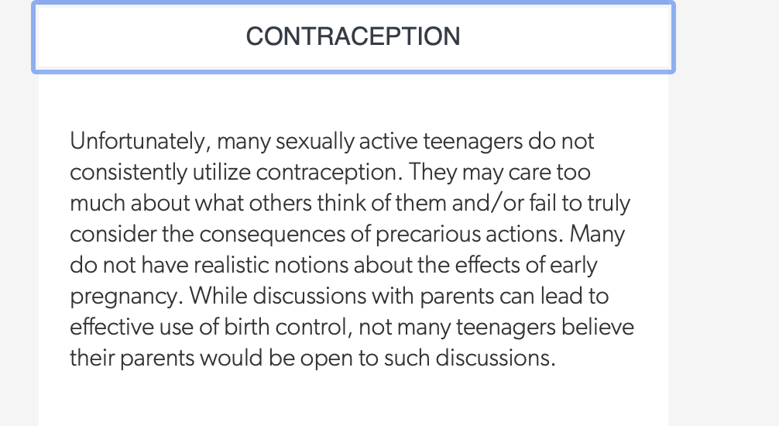

THIS IS THE GRADING RUBRIC. AFTER YOU HAVE COMPLETED IT, MAKE SURE IT HAS ALL OF THESE THINGS:

- The project clearly covers the requirements listed in the instructions:
- Start off by introducing the issue – give a brief summary about it.
- Who is affected by the issue and how?
- What theories/concepts from the lesson material can help parents, caregivers, and/or professionals better understand the issue?
- What can parents, peers, and/or professionals do to help with this issue?
- What resources are available in your community to assist with this issue? If you can't find anything locally, broaden your search to state and national service. Share at least 2 resources that offer help for the issue. Make sure to include the name of the agency, a summary of the services they provide, and contact information.
- Provide a brief conclusion of your presentation or informational pamphlet.
- Provide a summary for your instructor. You may share what you learned by completing this assignment, any challenges you faced, any information you didn't agree with, and/or any other relevant information you'd like to share.

- Project was well organized and easy to follow.

- Few to no spelling, grammar, punctuation or other writing structure errors

- Project meets length requirement

- Cover page, citations, and Reference list were in the correct APA format.

- Readings and at least 2 other sources were used.

